Please complete all the following details which will be verified by authorized representatives as part of the background screening process. All details are compulsory.

PERSONAL DETAILS
Name of Applicant: Aprameya Surname: A First: Aprameya Middle:
Date of Birth (DD/MMM/YY): 24/03/2003 | Marital Status: Unmarried  Date of Marriage: NA | National ID No: (Aadhaar Card)  3323 6847 2552
Place of Birth: Kolar | Nationality: Indian | Mobile: 7892668295
Sex: Male | Passport No.: X3628254 | E-mail ID: aprameyaa2403@gmail.com
Blood Group: O+ | SSN Number: | Pan Number : EIGPA7052G
Have You Changed Your Name? : Yes / No, (if Yes Please attach a copy of the name change document) No
Father’s Name: Arun Kumar R
Mother’s Name: Veena
Emergency contact Number:  9845716550 | Concern person Name:  Veena |  | Relationship:  Mother

RESIDENTIAL ADDRESSES (list in full all home addresses where you have resided at during last 07 years including overseas addresses) *Please add more rows if required.
Tenure of Stay (MMM/YY to MMM YY) | COMPLETE ADDRESS with Main, Cross, Area/Locality etc.. | CITY | POSTAL CODE | LAND MARK
Present Address: | #457 Ground Floor, 2nd main, Kanishka Maharaja Road, Bhavani Nagar,  Bangalore - 19 | Bangalore | 560019 | Behind Amba Bhavani Temple
Alternative Mobile: | 7624957729
Permanent Address: | #457 Ground Floor, 2nd main, Kanishka Maharaja Road, Bhavani Nagar,  Bangalore - 19 | Bangalore | 560019 | Behind Amba Bhavani Temple
Alternative Mobile: | 7624957729

EDUCATION DETAILS
QUALIFICATION | NAME & ADDRESS OF SCHOOL / COLLEGE/ INSTITUTE | NAME & ADDRESS OF BOARD/UNIVERSITY TO WHICH THE SCHOOL  / COLLEGE / INSTITUTE IS AFFILIATED TO | COURSE ATTENDED (PART TIME/ FULL TIME) | MARKS (%) CGPA  & CLASS | DATES ATTENDED |  | ROLL NUMBE  R/ REGISTR ATION NUMBE R/EXAM  SEAT NUMBE R
 |  |  |  |  | YEAR OF ENROLMENT (MM/YY) | YEAR PASSED (MM/YY)
HIGH SCHOOL (10TH STANDARD) | Chinmaya Vidyalaya -  44GJ+X93, PC Extn, Kolar, Karnataka 563101 | Karnataka Secondary Education Examination Board -  6th Cross Rd, Malleswaram, Bengaluru, Karnataka 560003 | Full Time | 96.96%  Distinction | March 2018 | April 2019 | 20190555541
INTERMEDIATE (12TH STANDARD) | Kumaran’s Comp PU College, Padmanabhanagar, Brindavan Layout, Bangalore - 560061 | Department of Pre-University Education -  18th Cross Road,18th Cross Road, Sampige Rd, Malleswaram, Bengaluru, Karnataka 560012 | Full Time | 91%  Distinction | May 2020 | July 2021 | 714312
GRADUATION | SJB Institute of Technology - No.67, BGS Health & Education City, Dr. Vishnuvardhan Rd, Kengeri, Bengaluru, Karnataka 560060 | Visvesvaraya Technological University -  QFH7+497 Jnana Sangama, VTU Main Rd, Visvesvaraya Technological University, Machhe, Belagavi, Karnataka 590018 | Full Time | 8.58 CGPA  First Class with Distinction | Nov 2021 | June 2025 | 1JB21IS012
DEGREE:
Bachelor of Engineering (BE)

SPECIALIZATION:
Information Science & Engineering

POST-GRADUATION | NA
DEGREE:

SPECIALIZATION:
ANY OTHER COURSE (PROFESSIONAL) | NA
DEGREE/DIPLOMA:

SPECIALIZATION:

EMPLOYMENT RECORD: Starting with your present or most recent employer, please list last 3 employments. When listing consulting or temporary assignments, under “Employer”, state the name of the consulting or temporary agency that placed you at the client site. Complete and accurate dates (month/year) must be provided.
CURRENT (or recent last) Company Name: |  | Employee Id: | From (DD/MM/YY): |  | To(DD/MM/YY):
Street Address: |  |  | Employer’s Phone No.: |  | Fax No.:
City: | State: | Country: |  | Postal Code:
Job Title: |  | Reason for Leaving:
Employment Status: (Please check the relevant box)  Full Time  Contract /Through Outsourcing Agency  Outsourcing Agency Details:  Name:  Address: |  | Supervisor’s/ Reporting Manager Details:
 |  | Name:
 |  | Title:
 |  | Phone No.:
E-mail id:
(Preferably official)
 |  | HR Manager’s Details:
 |  | Name:
Deputed location: |  | Phone No.:
E-mail id:
(Preferably official)
Gross Salary : |  | Per Month (Take Home): | Per Annum (CTC):
Please confirm if the current employer can be contacted for a verification at this time – Yes/No/Can be contacted after DATE.

EMPLOYMENT RECORD CONTINUED:
EMPLOYER 2: |  | Employee Id: | From(DD/MM/YY): |  | To(DD/MM/YY):
Street Address: |  |  | Employer’s Phone No.: |  |  | Fax No.:
City: | State: | Country: |  | Postal Code:
Job Title: |  | Reason for Leaving:
Employment Status: (Please check the relevant box)  Full Time  Contract /Through Outsourcing Agency  Outsourcing Agency Details:  Name: Address: |  | Supervisor’s/ Reporting Manager Details:
 |  | Name:
 |  | Title:
 |  | Phone No.:
E-mail id:
(Preferably official)
 |  | HR Manager’s Details:
 |  | Name:
Deputed location: |  | Phone No.:
E-mail id:
(Preferably official)
Gross Salary : |  | Per Month (Take Home): | Per Annum (CTC):
Please confirm if the current employer and the stated employer have any relationship with each other.

EMPLOYMENT RECORD CONTINUED:
EMPLOYER 3: |  | Employee Id: | From(DD/MM/YY): |  | To(DD/MM/YY):
Street Address: |  |  | Employer’s Phone No.: |  |  | Fax No.:
City: | State: | Country: |  | Postal Code:
Job Title: |  | Reason for Leaving:
Employment Status: (Please check the relevant box)  Full Time  Contract /Through Outsourcing Agency  Outsourcing Agency Details:  Name:  Address: |  | Supervisor’s/ Reporting Manager Details:
 |  | Name:
 |  | Title:
 |  | Phone No.:
E-mail id:
(Preferably official)
 |  | HR Manager’s Details:
 |  | Name:
Deputed location: |  | Phone No.:
E-mail id:
(Preferably official)
Gross Salary : |  | Per Month (Take Home): | Per Annum (CTC):

GAP Records: Please mention the reason & period of gap between 2 Qualification, Highest Qualification & Ist Employment and between 2 Employments.
GAP 1:
GAP 2:
GAP 3:
GAP 4:
GAP 5:

REFERENCE DETAILS: Please provide details of Two References along with their contact details and your relationship with the person.
Full name of Referee 1: Vaishnavi M S | Full name of Referee 2: Sanjay K S
Relationship with Referee: Sister | Relationship with Referee: Brother
Organization & it’s Address: Hewlett Packard Enterprise (HPE) - Mahadevapura Main Rd, near DNR Casablanca, B Narayanapura, Mahadevapura, Bengaluru, Karnataka 560048 | Organization & it’s Address: Infosys - Plot No, 44, Hosur Rd, Konappana Agrahara, Electronic City, Bengaluru, Karnataka 560100
Job Title: Financial Analyst | Job Title: Team Lead - IBPM
Office Number: 9945342200 | Office Number: 7259711122
Mobile: 9945342200 | Mobile: 7259711122
E-mail Id: Vaishnavirao.ms@gmail.com | E-mail Id: spsahusanjay16@gmail.com

AUTHORIZATION LETTER
I certify that the statements made in this application are valid and complete to the best of my knowledge. I understand that false or misleading information may disqualify me from employment and /or result in termination of employment.

I understand that LKQ India Private Limited may request a verification of information provided by me and /or background check from an agency hired by LKQI for this purpose.

I hereby authorize my current/prospective employer LKQ India Private Limited and/or any of its subsidiaries or affiliates or partners or vendors,

I further understand that the results of verification and checks and any records made out of that information will be used for employment purposes only and will not be given to unauthorized persons.

I authorize LKQ India Private Limited to conduct a verification and background check including but not limited to the verification and check of information, references and Criminal Conviction records (If Applicable) stated by me in this application for the consideration of LKQ India Private Limited employment to be used only for my employment purposes.

I also authorize all the concerned persons, authorities, organizations, their employees, agents or authorized representatives, whether named in the application or not, to release the information in their knowledge / possession / records relevant to my employment.

In the event that LKQ India Private Limited and /or its agents are unable to verify any information and references stated in this application, it is my responsibility to furnish the necessary documentation in support of that information.

I fully understand that this application or subsequent employment does not create a contract of employment nor guarantee employment for any definite period of time and my employment decision will always be at the sole discretion of LKQ India Private Limited.

I have read, understood, and by my signature consent to these statements.
Member SIGNATURE: 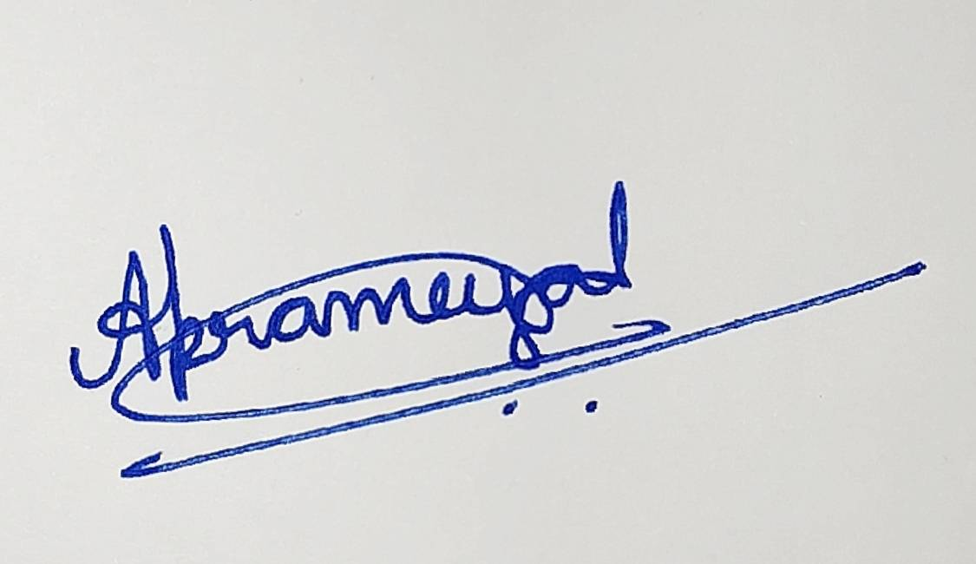  Mention NAME (IN BLOCK LETTERS): APRAMEYA A  MOTHER’S MAIDEN NAME (IN BLOCK LETTERS): VEENA  PAN #: EIGPA7052G | DATE:  1st Oct 2025 | Affix passport photo here  

